CSS GRID

index.html
<html>
<head>
<title>CSS Grid crash course</title>
<link rel="stylesheet" href="style.css">
</head>
<body>
<div class="container">
<div class="item1"></div>
<div class="item"></div>
<div class="item"></div>
<div class="item"></div>
<div class="item"></div>
<div class="item"></div>
<div class="item"></div>
<div class="item"></div>
<div class="item"></div>
<div class="item"></div>
</div>
</body>
</html>

Style.css
.container{
background-color: yellow;
height:700px;
width:1000px;
display:grid;
* grid-template-columns: 100px 100px 100px 100px 100px 100px 100px 100px 100px 100px ;/
/this specifies how many columns you want
grid-template-rows: 133px 133px 133px 133px;
*/
//this specifies that we want to repeat the colmns three times and equally distribute
grid-template-columns:repeat(3,1fr);
grid-template-rows:repeat(3,1fr);
row-gap:3px;
column-gap:3px;

}

.item{
background-color:red;
/* height:130px;
width:90px; */
}
//the below will make the item 1 to span two columns
.item1{
background-color:blueviolet;
grid-column-start:1;
grid-column-end:3;
}

Output
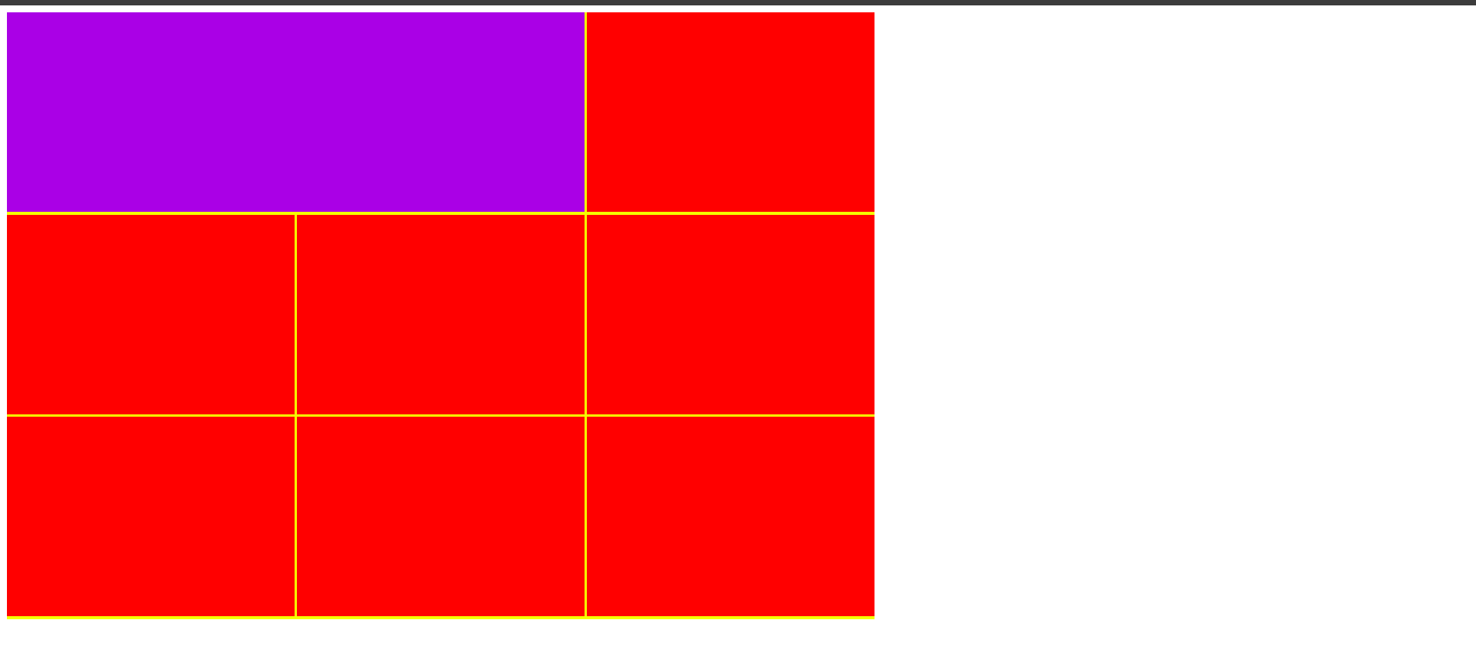
GRID TEMPLATE CHANGE
grid-template-columns: 1fr 1fr 1fr;
grid-template-rows: 133px 1fr 1fr;

.container{
background-color: yellow;
height:700px;
width:1000px;
display:grid;
/*we can also specify individually for each row*/
grid-template-columns: 1fr 1fr 1fr;
grid-template-rows: 133px 1fr 1fr;
row-gap:3px;
column-gap:3px;
}
.item{
background-color:red;
}

.item1{
background-color:blueviolet;
grid-column-start:1;
grid-column-end:4;
}

the above will do that size of our first row should be 133px .the item1 will span from colmn 1 to 4.
